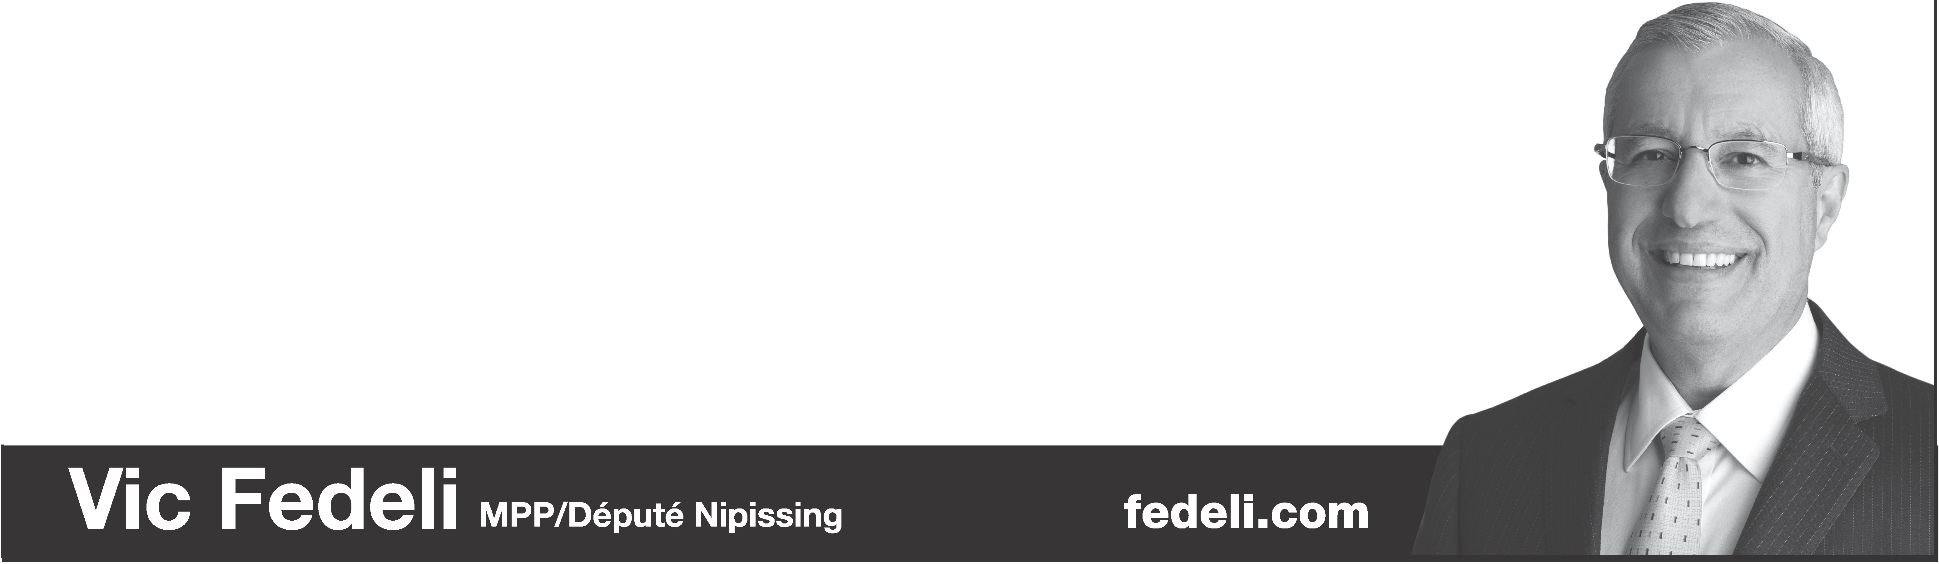

**Please join us June 13th, 6:30 pm at the Mattawa Council Chambers for**

**FLOOD ASSISTANCE INFORMATION**

Staff from the Ministry of Municipal Affairs and Housing will give a presentation on the Disaster Recovery Assistance for Ontarians program, including info on eligibility criteria, supporting documentation requirements and how to apply. After the presentation, residents will have an opportunity to speak with staff from the ministry and my office to ask questions.

[**www.ontario.ca/disasterassistance**](http://www.ontario.ca/disasterassistance)for program guidelines, FAQ's and application forms. Application assistance and questions: [**disasterassistance@ontario.ca**](mailto:disasterassistance@ontario.ca)or call **1-844-780-8925**

**Please be advised that staff from the Ministry of Municipal Affairs**

**will also be available at the**

**Municipal Office Council Chambers, 160 Water Street:**

**Friday June 14th, 2019**

**9 am – 12 Noon**

**and**

**1pm – 3 pm**

**To meet with potential Disaster Recovery Assistance for Ontarians (DRAO) applicants and answer questions they have about the application process**